Version September 27,2023

[jorgen.randers@bi.no](mailto:jorgen.randers@bi.no)

**FORECASTING GLOBAL ENERGY USE TOWARDS 2060**

Written version of

presentation to session Work In Progress 186 to ISDC 2023 in July 2023.

Jorgen Randers and Ulrich Goluke

BI Norwegian Business School, Oslo, Norway

**Abstract**

We report that global energy use (the sum of electricity and heat) per person can be approximated by the formula y = a * ( 1 - EXP( - x / c ) ) * ( EXP( - ( year – 1980 ) / d ) ) where y = energy use per person in tons of oil equivalents per year per person, x = GDP per person in thousand 2017 PPP $ per year per person, a = 25, c = 100 and d = 60.

We derived the formula and the parameters from time series data for 10 global regions and for the world total from 1986 to 2019, using conventional UN data.

We drive the formula with consistent time series for population and GDP per person from a business-as-usual scenario (“TLTL”) generated by our Earth4All simulation model of world development from 2020 to 2100.

We calculate future energy use as population times energy use per person and conclude that total energy use will grow to a peak before 2040, at a level which is only some 25 % higher than current energy use.

Our forecast is well below lay expectations but is supported by professional studies like the DNV-GL Energy Transition Outlook 2023. The precision level is low, but the dynamic is robust.

**FORECASTING GLOBAL ENERGY USE TOWARDS 2060**

Jorgen Randers and Ulrich Goluke

BI Norwegian Business School, Oslo, Norway

**Full text**

**We want to forecast total energy use (both heat and electricity) for the world in the long run towards 2060.**

Our ambition is only to achieve a very rough estimate – essentially a forecast of general trends, and certainly not exact values for a specific future year. This is because we base the forecast on highly aggregate time series data from standard UN-source, which has significant measurement error. And because we wanted to find a forecasting method that is simple enough to do on a laptop in a few seconds.

We define total energy use as the sum of the energy in the amount of fossil fuels used (measured in Mtoe/y) plus the energy in the amount of non-fossil electricity used (measured in TWh-electricity/y). Non-fossil electricity includes hydro, nuclear, solar, and wind power.

This means that we disregard energy from biomass (primarily due to lack of data, but we consider it unproblematic since the use of biomass is limited in a global perspective: the omission does not introduce an error which is much bigger than the measurement error in the time series data we have.

**We add heat and electricity into one intuitive measure of energy.**

We add the two types of energy use into one common measure (Mtoe/y) by adding the energy content in the fossil fuels used (measured in Mtoe/y) and the energy content in the fossil fuel one would have had to burn in a modern power station to produce the observed amount of non-fossil electricity (also measured in Mtoe/y). This means we multiply the observed use of non-fossil electricity in TWh-electricity/y with a constant conversion factor of 4 TWh-electricity per 1 Mtoe fossil fuel, to get non-fossil electricity use in Mtoe/y. Fig A shows historical data for fossil energy use FEU and non-fossil energy use NFEU and the sum EU – all of them expressed in Mtoe/y. Most energy came and still comes from fossil fuels (some 80% in our reconning), but the fraction of non-fossil energy f = NFEU/EU has started to increase, and the world ambition is to make it reach 1 around the middle of this century.

**We have data for energy use, population, GDP since 1980 for the world and for its 10 regions.**

The historical data takes the form of annual time series data for

1. population POP in Mp,
2. GDP in 2017PPP$/y,
3. fossil energy use FEU in Mtoe/y,
4. non-fossil electricity use NFELU in TWh-el/y

From which we can calculate time series for

1. GDP pr person in thousand 2017PPP$/y/p (hereafter abbreviated k$/y/p)

= GDP G$/y / POP Mp

1. non-fossil energy use NFEU in Mtoe/y

= NFELU TWh/y * 4 Mtoe/TWh-el,

1. total energy use EU in Mtoe/y

= FEU Mtoe/y + NFEU Mtoe/y, and

1. energy use per person EUpp in toe/y/p

= EU Mtoe/y / POP Mp

both for the world and for 10 regions.

Fig B illustrates the resulting historical time series for POP Mp, GDP G$/y, GDPpp k$/y/p, EU Mtoe/y and EUpp toe/y/p for the world (for regional data see supplementary information).

**We see a stable and understandable pattern in the relationship between EUpp vs GDPpp - when both are measured in appropriate units.**

Fig C shows the result when we present the historical data for EUpp as a function of GDPpp.

The raw data in the figure makes good causal sense if interpreted as the result of the following functional form

y = a * ( 1 - EXP( - x / c ) ) * ( EXP( - ( year – 1980 ) / d ) ) Formula 1

Where y= EUpp toe/y/p, x = GDPpp k$/y/p and a, c and d are constant parameters estimated to give the best fit of EUpp and GDPpp to historical values. (It turns out that a=25, c=100, d=60 gives a good fit to world data, and with small changes in reasonable fit to the regional data).

The first part a * ( 1 - EXP( - x /c ) ) of formula 1 represents the fact that more energy is used at higher income levels – which in turn requires higher GDP per person. But energy use grows at declining rates when the nation gets richer. One reason for this decline is the unavoidable sector shift – from manufacturing towards less energy-intensive services and care – that occurs when a nation gets richer.

The second part EXP( - ( year – 1980 ) / d ) represents the steady rise in energy efficiency which occurs as a consequence of general technological advance. Estimation gives d = 60, which means that energy efficiency has grown at a rate of 1/60 around 1.6 %/y during the last 40 years. This is a high rate, which explains why the energy use per household in rich countries like the US (and Norway) has been declining over the last several decades (might illustrate with an additional graph?).

**We extract - from historical data - the parameter values in formula 1 for EUpp.**

We find the parameters a, c and d by fitting formula 1 to historical data for EUpp and GDPpp – both for the world and for 10 regions**.** We do this in two ways a) by fitting formula 1 to the global data (to obtain what we call “the global guide”) and b) by fitting formula 1 to data from each of 10 regions (to obtain what we call 10 “regional guides”). In both cases we use annual time series for EUpp and GDPpp 1986 to 2020 (in some cases, less because of lack of data). The fitting leads to the following parameter estimates a = 25 (varying from 20 to 30 among regions) c= 100 (varying from 90 to 110) among regions and d = 60 (which we do not vary among regions, since it is a global trend).

The fitting was done by visual inspection but could have been done through formal minimum lest squares deviation data and formula. Fig D illustrates the match between the global guide and global data and the fit between the regional guide for the US and data for the US.

We interpret the differences in parameter values to represent differences in regional traditions, institutions, and priorities. We are surprised that the variation is so small, given the vast number of regional differences we try to capture in one simple functional form.

**We calculate future EUpp by driving formula 1 for EUpp with time series for GDPpp from a global simulation model (E4A). And then we calculate future energy use by multiplying with future POP from the same model.** In order to calculate the time development of EU, one needs consistent time-series data for GDPpp (to get EUpp from formula 1) and POP (to get total energy use EU = EUpp * POP). Ideally the two time-series should be obtained from one global simulation model, to ensure that the two time-series are internally consistent.

We use time series data from the “decision making as usual” scenario (“TLTL”) generated by our global simulation model E4A (see [www.earth4all.life](http://www.earth4all.life)) to calculate future energy use (see Fig E – showing GDP, GDPpp and POP from TLTL to 2100).

But in lack of such, other users can derive his/her own time series for GDPpp and POP and use them to estimate future energy use.

**We forecast a peak in global energy use in the 2030s.**

The result is shown in Fig F – showing EU and EUpp to 2100.The figure shows that global energy use has doubled since 1980 and will continue to increase. But at decreasing rates towards a peak in the 2030s at a level which is only some 20 % higher than current energy use.

This peak is much earlier and a much lower value than what is normally assumed in the public debate about global energy needs in this century. But it is supported by the conclusions of DNV-GL in their *Energy Transition Outlook 2023*, which is based on their detailed energy simulation model. The early and low peak is an advantage in the sense that will reduce the amount of non-fossil capacity that must be built to complete the transition to a emission free energy system.

The main reasons for the low and early peak in spite of continuing growth in GDPpp are that we assume (as does the TLTL scenario)

a) a peak in the world population before 2050,

b) continued increase in energy efficiency at historical rates, and

c) continued “declining marginal increase” in the use of energy as the nation increases its GDPpp.

Since the cost of non-fossil energy is higher than that of fossil energy, we may see a further reduction in EUpp at a given GDPpp a – if the extra per unit of energy cost is passed on to consumers.

**The uncertainty in the forecast is big, but the general pattern of rise and decline is robust.**

Sensitivity analysis can be done – varying the coefficients a, c, d inside the range obtained for different regions. But as long as we require the alternative set of parameters to be able to recreate history, such sensitivity analyses do not invalidate our conclusion. We believe the uncertainty range in EU is of the order of +-5 %, perhaps +-10%.

**Limited difference between forecasts based on global or regionalized models.**

In order to test the robustness our forecast we made separate energy forecasts for each of the 10 world regions and summed the result – and compared with the global forecast. More concretely we calculated future energy use per region using regional data only, thereby obtaining the regional version of formula 1. We then drove the regional formula with consistent values for POP and GDPpp for that region – obtained from the regionalized version of the E4A model).

Fig F shows the resulting forecasts for EU. The two forecasts are relatively similar. The differences that exist (a delayed peak at a slightly lower value) are the effect of disaggregation – of maintaining regional differences throughout the forecasting process. The effect of disaggregation was and makes it defendable to use the much simpler method of global forecasting based on global data. The precision level in the forecast is low anyway and does not warrant the 10 doubling of the effort needed to move from a global to a regional analysis. But it is useful to know that this is so in the case of EU. And important to remember that this will not necessarily be the case for the aggregation of other variables in the world system.

In sum there appears to be limited effect of disaggregation in this case, so as long as one is only after general results one may as well use a global (un-regionalized) model and the global guide to forecast global energy use.

**Practical application to forecasting CO2 emissions from energy.**

Our method for forecasting total energy use makes it simple to estimate future CO2 emissions from energy use. The production and use of 1 Mtoe of fossil fuels leads the emission of some 2.5 MtCO2 irrespective of how the fossil fuel is used. The production and use of 1 Mtoe of non-fossil electricity leads to much smaller emissions (0.1 MtCO2(?) and close to zero in best cases). So global emissions can be estimated as

CO2e (in MtCO2/y) = FEU (in Mtoe/y) * 2.5 MtCO2/Mtoe + NFEU (in Mtoe/y) * 0.1 MtCO2/Mtoe = EU (in Mtoe/y) * ( (1-f) * 2.5 + f * 0.1) MtCO2/Mtoe

Formula D shows that annual emissions will fall as f increases from its current value around 0.2 (?) towards 1 later in the century.

Formula D also shows that the peak in emissions CO2E will occur before the peak in EU (since f is a monotonically increasing function of time).

We need to correct/adjust this estimate if the world chooses to introduce CCS (carbon capture and storage) in many plants using (burning or transforming) fossil fuels. If the fraction of fossil-driven plants with CCS increases, average emissions per ton of fossil fuel (in MtCO2/Mtoe) will decline. For the past and for the next decade the error done by disregarding this correction is negligible, but later the number of CCS plants may rise sufficiently to make this correction necessary. Anyway, disregarding CCS leads to a higher estimate of CO2E.

**Appendix**

This paper is based on the spreadsheet:

t230927 Graphs for ISDC 2023.xlsx

which is available from the authors.

**Figures**

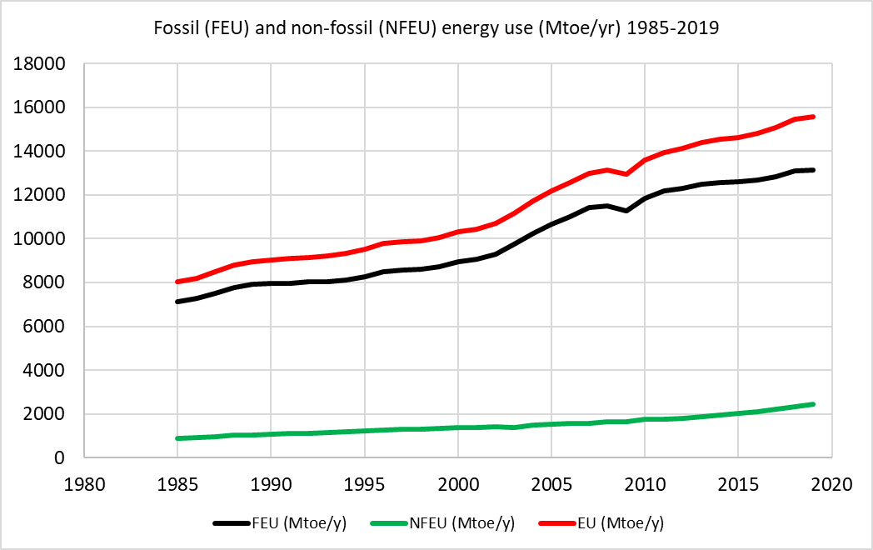

Fig A. Graph showing historical data for fossil energy use (FEU), and non-fossil energy use (NFE) and total energy use (EU) – World 1985 to 2019.

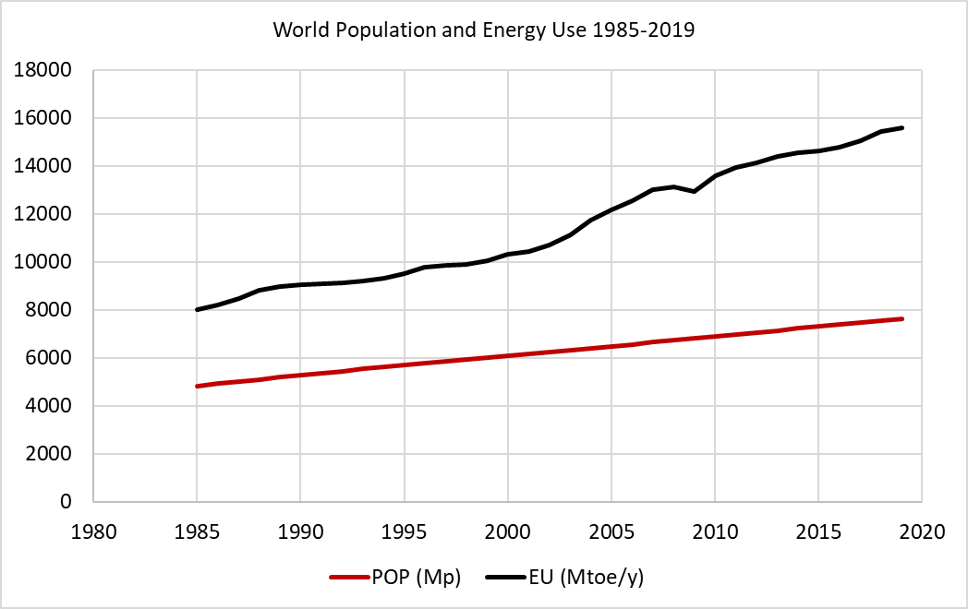

Fig B-1. Graph showing historical data for population (POP) and energy use (EU) – World 1985 to 2019.

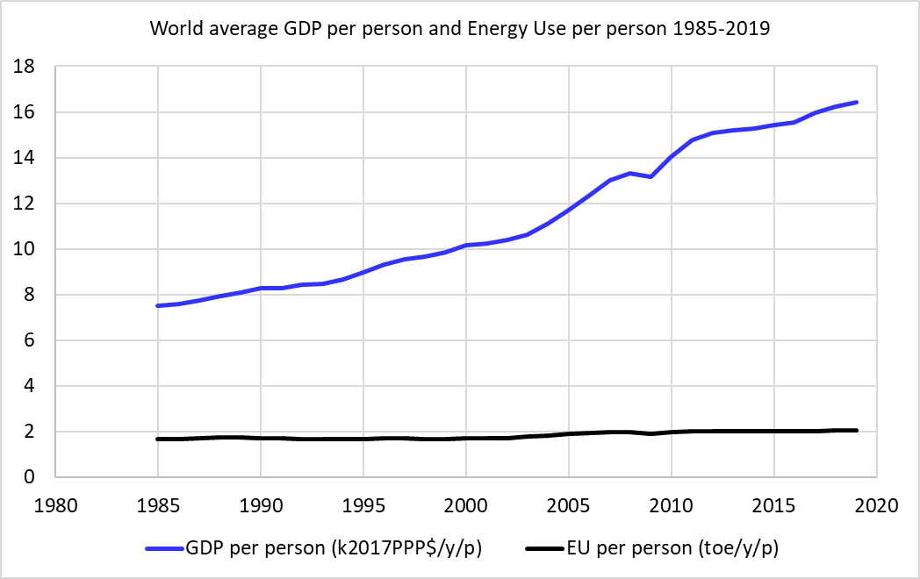

Fig B-2. Graph showing historical data for GDP and energy use (EU) per person – World 1985 to 2019.

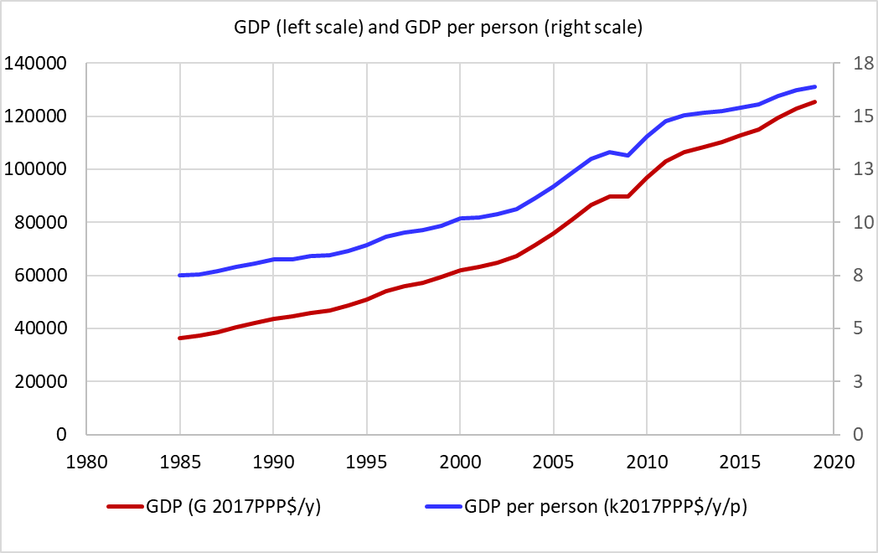

Fig B-3. Graph showing historical data for GDP and GDP per person – World 1985 to 2019.

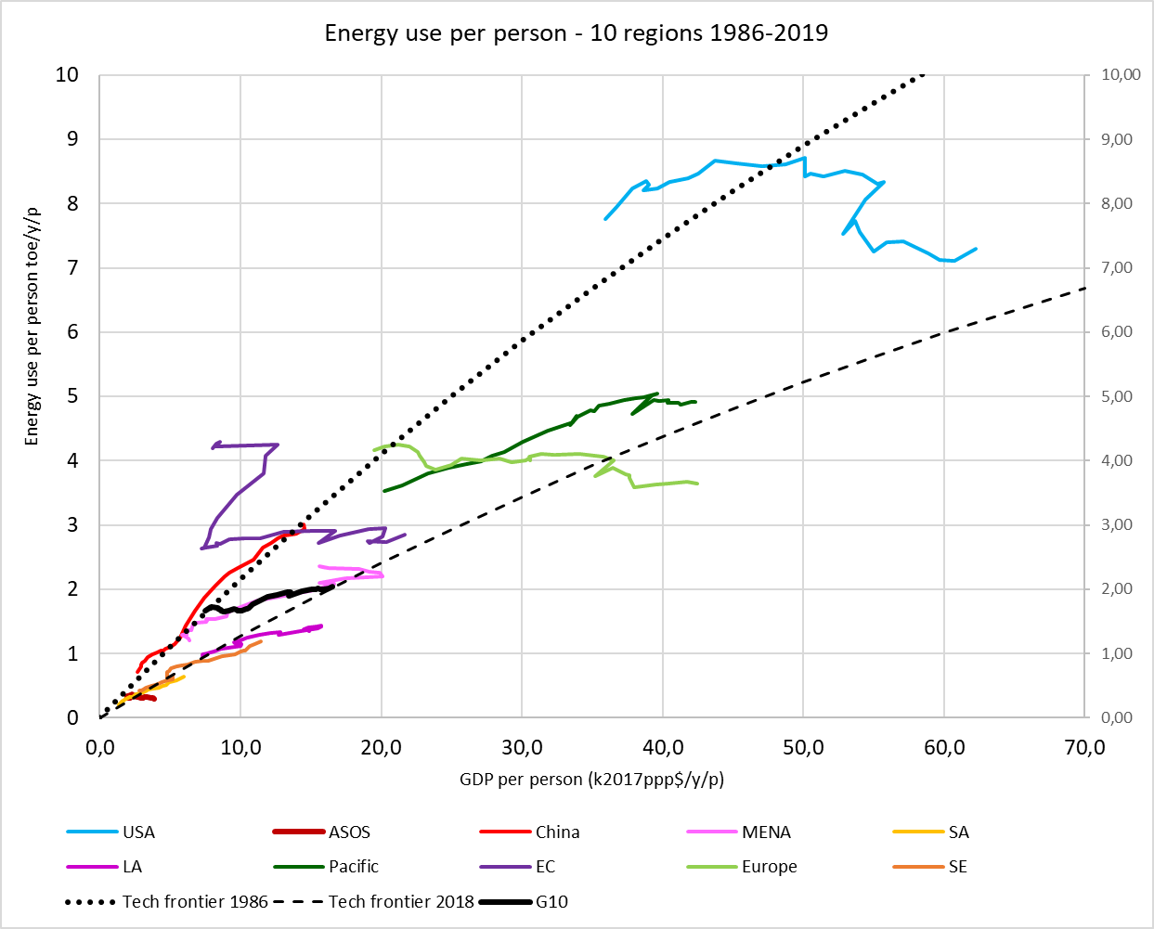

Fig C. Graph showing historical data for energy use per person – 10 regions plus world average 1980 to 2020. The black dashed curves show the best fit global guide (formula 1) for 1980 (top) and 2020 (bottom).

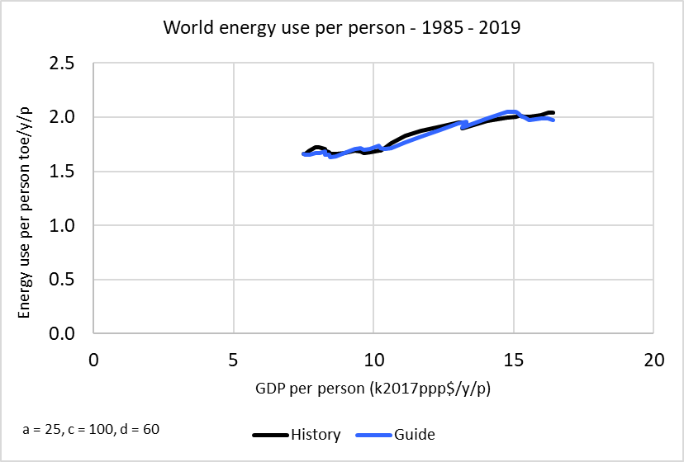

Fig D. The match between a) the global guide and global data 1986 to 2019 (left), and b) the regional guide for US and US data 1986 to 2019 (right)

Fig E-1. Graph showing development of GDP – World 1980 to 2100.   
(History 1980 to 2020 dotted.)

Fig E-2. Graph showing development of GDP per person – World 1980 to 2100.   
(History 1980 to 2020 dotted.)

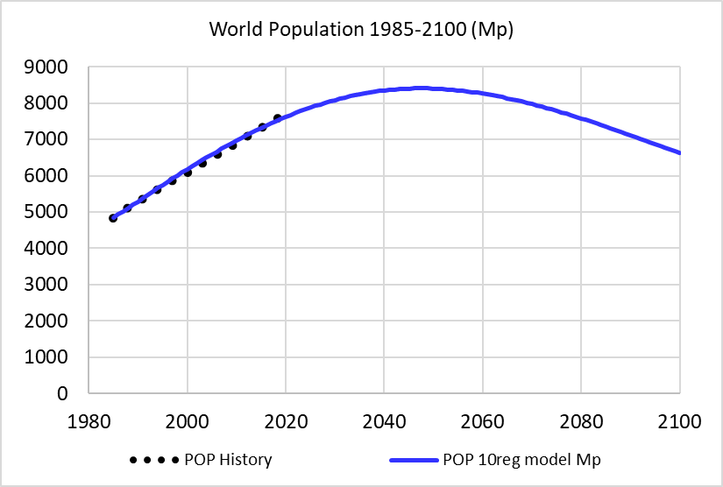

Fig E-3. Graph showing development of population – World 1980 to 2100.   
(History 1980 to 2020 dotted.)

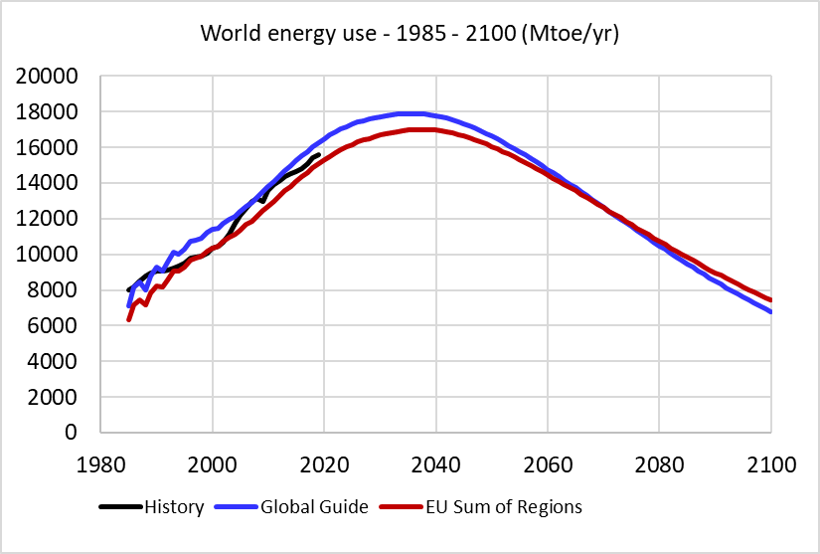

Fig F. Graph showing development of energy use from two different ways of forecasting – World 1980 to 2100. (History 1980 to 2020 dotted.) See text for details.